# 

|  |  |
| --- | --- |
| Four Seasons Hotel | Students  Presented by: Omar AL Zoghbi and Hasan Itani  Instructor  Oussama Hatoum |

# **1.Abstract**

The Hotel Management System is a comprehensive solution designed to streamline the process of room bookings and enhance user experience through a user-friendly website. This system allows users to browse available rooms, view detailed information, and make reservations conveniently from their devices.

The project integrates essential features, including room availability management, real-time booking updates, and a secure reservation process. By leveraging modern web technologies, the system ensures reliability, efficiency, and accessibility for both hotel administrators and guests.

This project aims to address the challenges faced by traditional booking methods by providing an intuitive platform that simplifies hotel management tasks and improves customer satisfaction. The system is scalable and adaptable, making it suitable for a wide range of hotel establishments, from small inns to large resorts.

# **2.Table of Contents**

0

**1.Abstract** 1

**2.Table of Contents** 2

**3.Acknowledgment** 4

**4.Project Overview** 5

**4.1.Problem** 5

1. **4.1.1.Manual Booking Processes** 5

2. **4.1.2.Limited Accessibility** 5

3. **4.1.3.Lack of Convenience** 5

4. **4.1.4.Inconsistent Communication** 5

5. **4.1.5.Administrative Challenges** 5

**4.2.Purpose of our system** 5

**4.3.Target Audience:** 5

• **4.3.1.Hotel Managers and Staff:** 5

• **4.3.2.Developers:** 5

• **4.3.3.Stakeholders:** 6

• **4.3.4.End-Users (Guests):** 6

**4.4.Features Overview:** 6

**4.4.1.Booking Management:** 6

**4.4.2.Staff Scheduling:** 6

**4.4.3.Guest Management:** 6

**5.ERD** 6

**5.1.ERD Diagram** 6

**5.2.ERD Values** 7

**6.Use-Case Diagram** 8

**7.Story Board** 9

**8.SnapShots** 12

**8.1.User Section** 12

**8.1.1.Home Page** 12

**8.1.2.Our Services** 13

**8.1.3.About Us** 14

**8.1.4.Contact Us** 15

**8.1.5.Login/Signup** 16

**8.1.6.Reservation** 17

**8.2.Admin Section** 21

**8.2.1.Client List** 21

**8.2.2.Room List** 21

**8.2.3.Employee list** 22

**8.2.4.Feedbacks** 22

**8.2.5.Client Requests** 23

**8.2.6.Add Room** 23

**8.2.7.Add Employee** 24

**9.Conclusion** 24

**10.Future Work** 25

**10.1.Mobile Application Development** 25

**10.2.Payment Integration:** 25

**10.3.Advanced Analytics:** 25

**10.4.Multilingual Support:** 25

**10.5.Loyalty Programs:** 25

**10.6.AI-Powered Recommendations:** 25

**Four Seasons Hotel Management System**

# **3.Acknowledgment**

We would like to express our heartfelt gratitude to Ousamma Hatoum for their invaluable guidance, encouragement, and support throughout the development of this hotel reservation system project. Their insights and expertise were instrumental in shaping the project's foundation and ensuring its successful completion.

We are also grateful to our classmates for their constructive feedback and collaboration, which motivated us to improve and innovate continuously. Their input has been invaluable in refining our ideas and enhancing the quality of our work.

We would like to extend our appreciation to our institution for providing the resources and learning environment that allowed us to acquire the skills necessary for this endeavor. The tools made available to us played a crucial role in bringing this project to fruition.

Finally, we express our deepest gratitude to our families and friends for their unwavering support, patience, and understanding throughout this journey. Their encouragement gave us the strength and determination to see this project through to completion.

# **4.Project Overview**

## **4.1.Problem**

The problem your Hotel Management System is solving revolves around the inefficiencies and limitations of traditional hotel booking methods. Here are the key problems your project addresses:

1. **4.1.1.Manual Booking Processes:** Traditional booking systems often rely on manual entry, phone calls, or in-person reservations, which can be time-consuming, error-prone, and inefficient.
2. **4.1.2.Limited Accessibility:** Customers may face difficulties in accessing information about room availability, pricing, and amenities without visiting the hotel or making direct inquiries.
3. **4.1.3.Lack of Convenience:** Guests expect the convenience of online booking platforms, where they can browse, select, and book rooms anytime and anywhere.
4. **4.1.4.Inconsistent Communication:** Traditional systems may struggle with real-time updates, leading to issues like double bookings or outdated room availability information.
5. **4.1.5.Administrative Challenges:** Hotel staff may face difficulties managing reservations, cancellations, and room availability without a centralized, automated system.

## **4.2.Purpose of our system**

The Four Seasons hotel management system was created to address the challenges of managing hotel operations efficiently. It aims to simplify tasks such as booking management, staff scheduling, and guest services. By automating these processes, the system reduces manual errors, saves time, and enhances the overall experience for both hotel staff and guests.

## **4.3.Target Audience:**

This documentation is intended for:

* **4.3.1.Hotel Managers and Staff:** To understand and utilize the system for daily operations.
* **4.3.2.Developers:** To maintain, enhance, or integrate the system with other tools.
* **4.3.3.Stakeholders:** To assess the system’s capabilities and performance.
* **4.3.4.End-Users (Guests):** If applicable, to navigate features like online booking or self-service options.

## **4.4.Features Overview:**

**4.4.1.Booking Management:** Streamline room reservations and manage availability in real time. Track and modify bookings with ease.

**4.4.2.Staff Scheduling:** Create, update, and delete staff. Check Clients service interaction with the staff.

**4.4.3.Guest Management:** Enhance customer satisfaction through personalized services. Maintain detailed records of guest preferences and history.

# **5.ERD**

## **5.1.ERD Diagram**

|  |
| --- |
|  |
|  |
|  |

## **5.2.ERD Values**

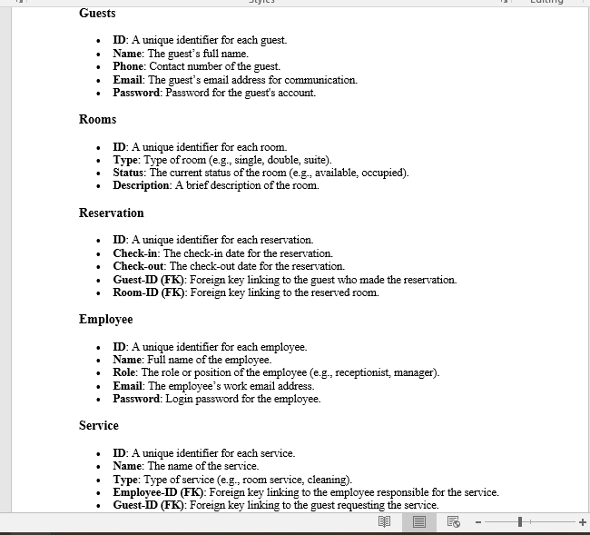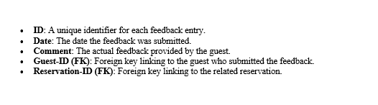

# **6.Use-Case Diagram**

|  |
| --- |
|  |
|  |

# **7.Story Board**

|  |  |
| --- | --- |
|  |  |
|  |  |
|  |  |
|  |  |
|  |  |
|  | |

# **8.SnapShots**

## **8.1.User Section**

### **8.1.1.Home Page**

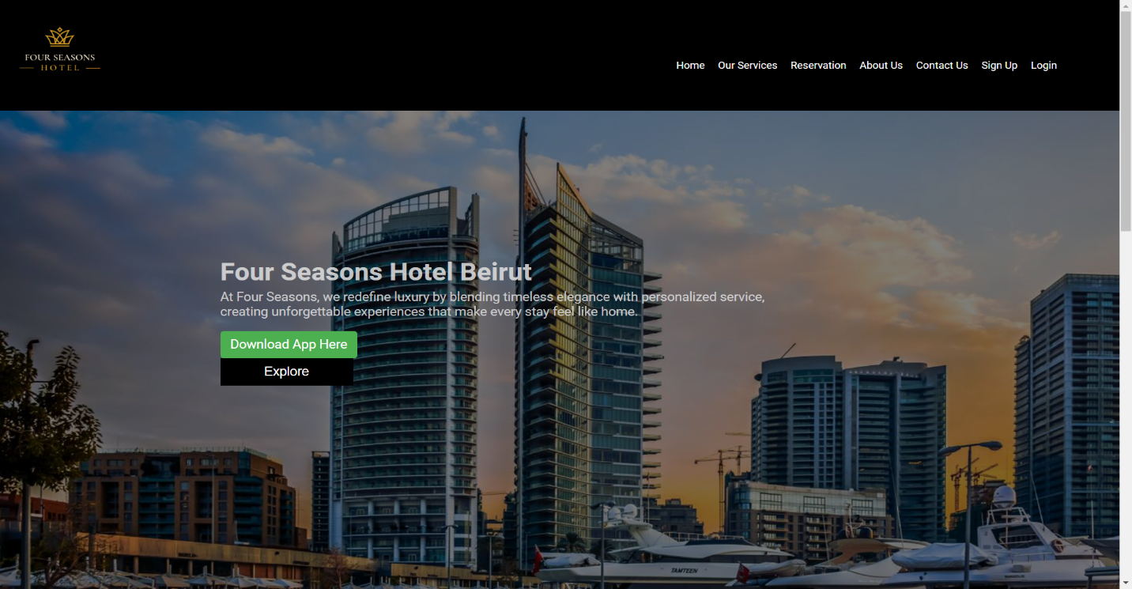

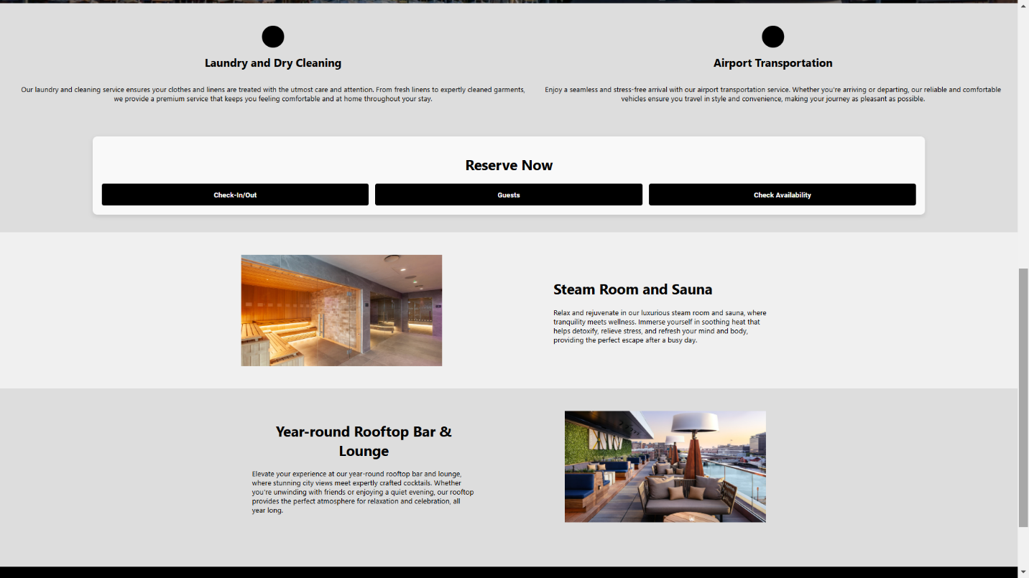

The home page would be the first thing for the user to be displayed with a navbar containing some other pages.

### **8.1.2.Our Services**

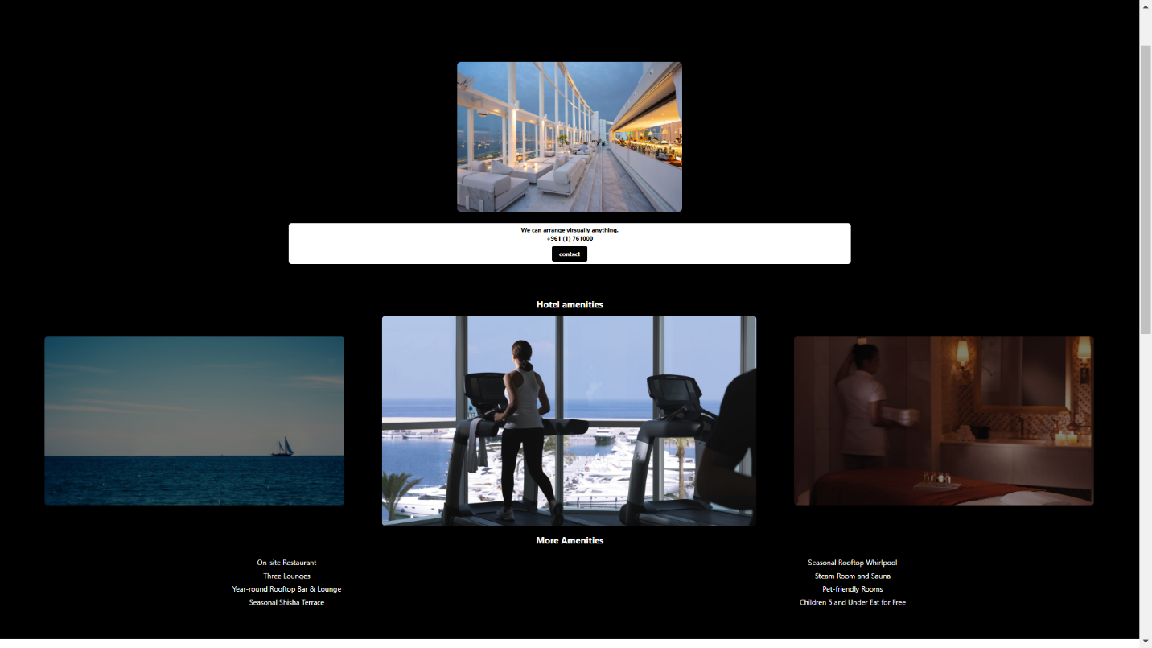

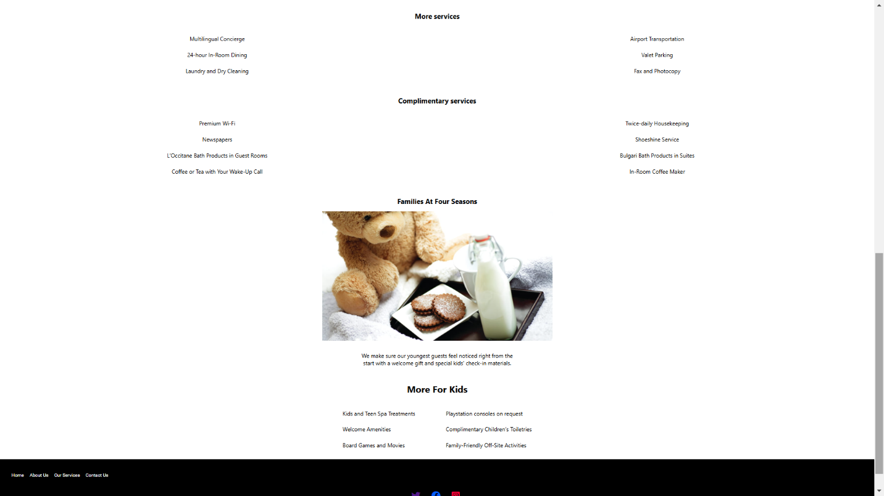

On our services the guest will explore what services the hotel will serve them and meet their expectations.

### **8.1.3.About Us**

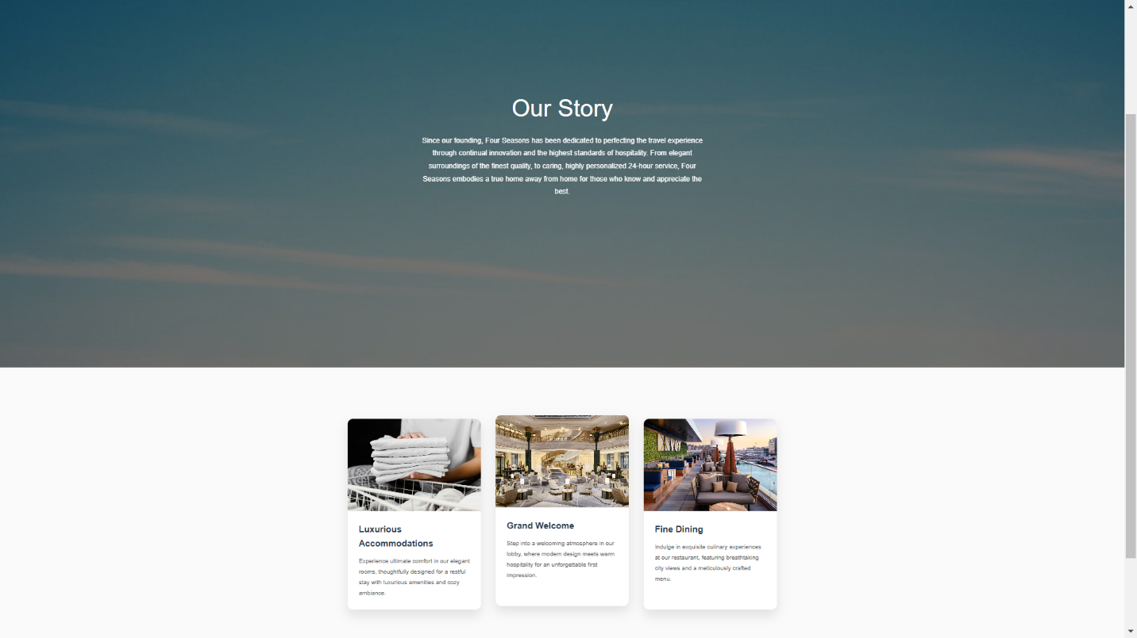

Over the years, Four Seasons has grown into an international icon, with over 100 properties in prime destinations across the globe. The brand's growth is a testament to its commitment to innovation, quality, and attention to detail. From urban retreats to exotic escapes, Four Seasons has always provided an exceptional environment for guests to relax, unwind, and indulge in the best of hospitality.

### **8.1.4.Contact Us**

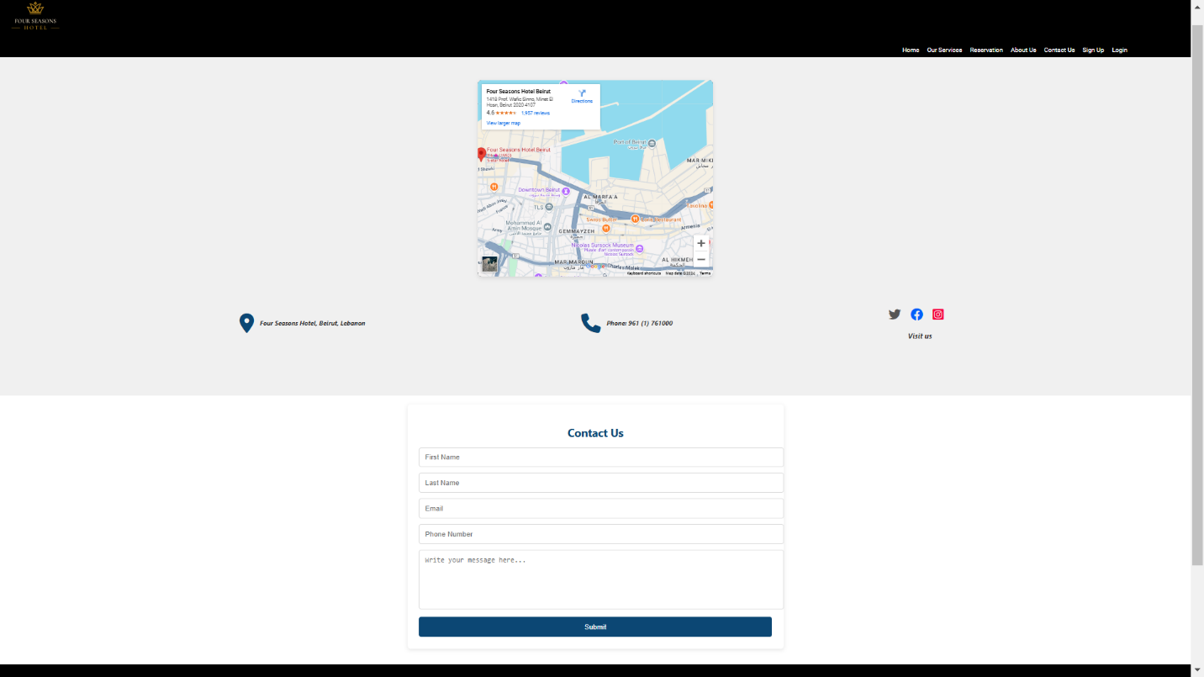

Through our Contact Us page, users can reach out to us for assistance, feedback, or inquiries. We encourage guests to follow us on our social media platforms to stay connected and informed about the latest news and promotions.

Connecting with Us on Social Media:

* Facebook
* Instagram
* Twitter

And to submit the form the guest should submit their First and Last name, Email, Phone Number, and lastly the Message

### **8.1.5.Login/Signup**

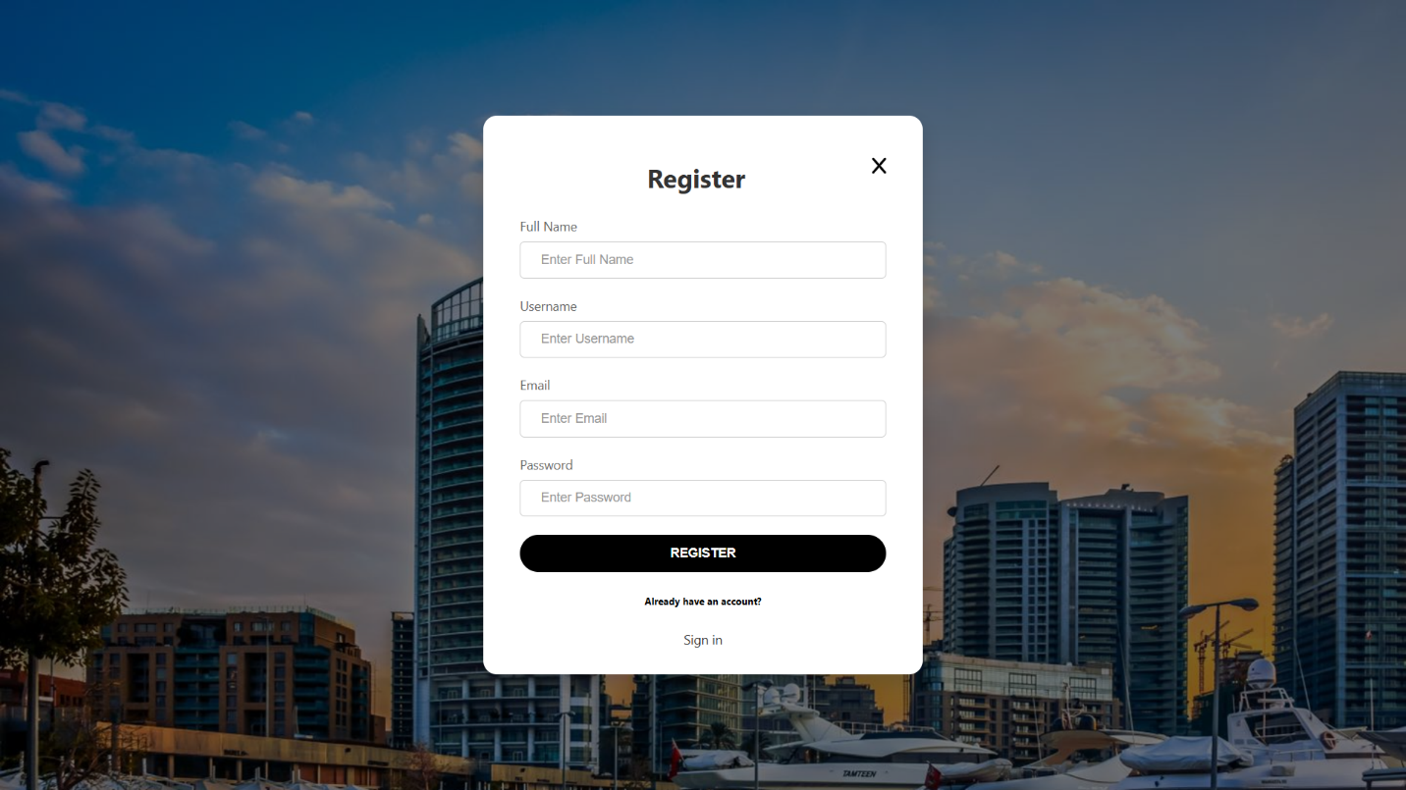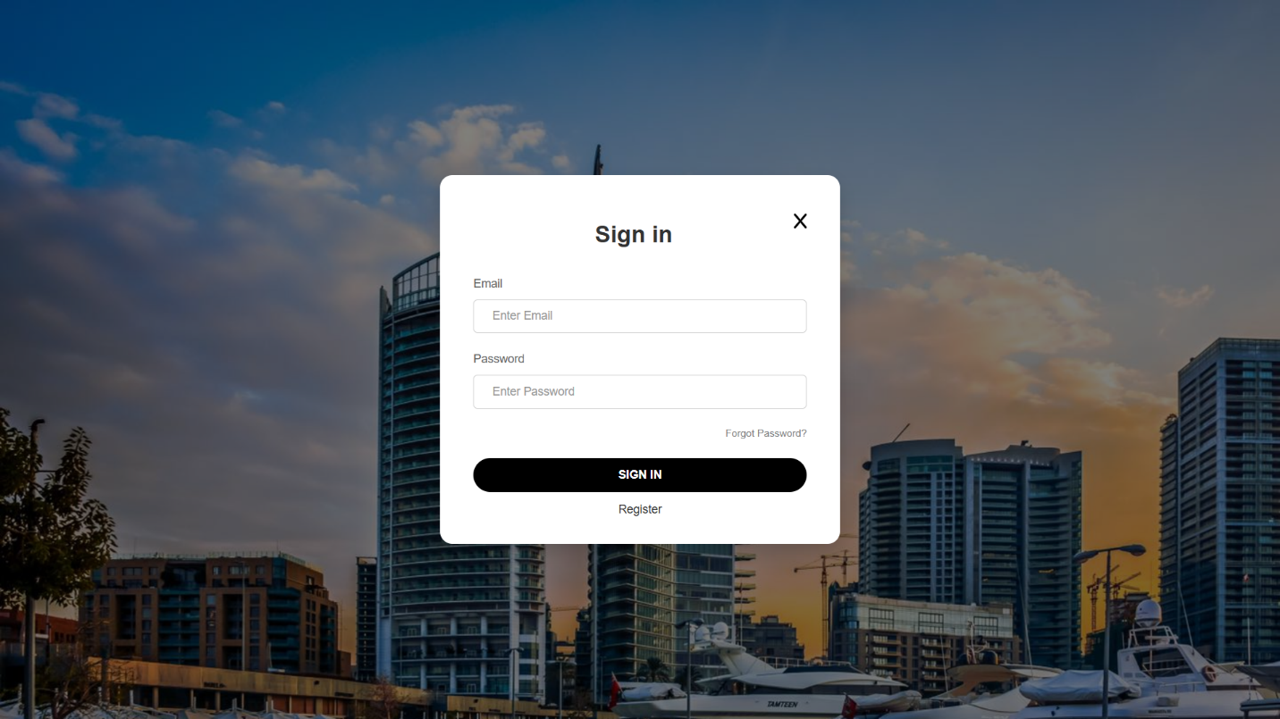

To able the guest to submit forms or to book a room as we will see soon, they must be logged in. The form for the signup need a Full name, Username, Email, Password, or if the user is already signed up but logged out he/she can login with their Email and Password.

### **8.1.6.Reservation**

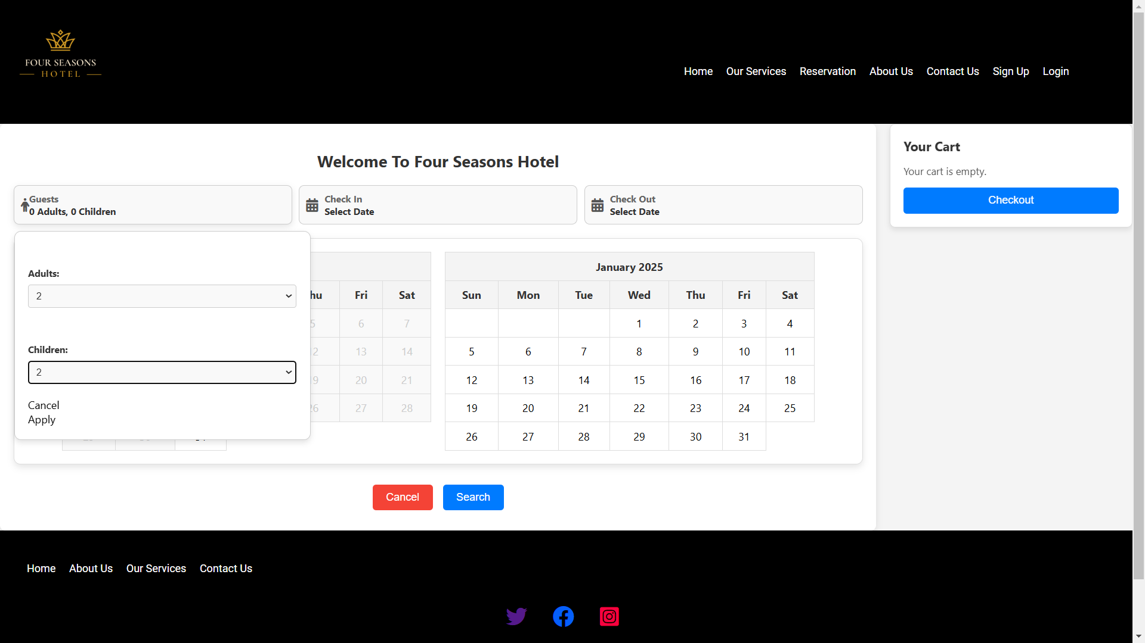

After the login, the guest will first select how many adults and children include on the booking,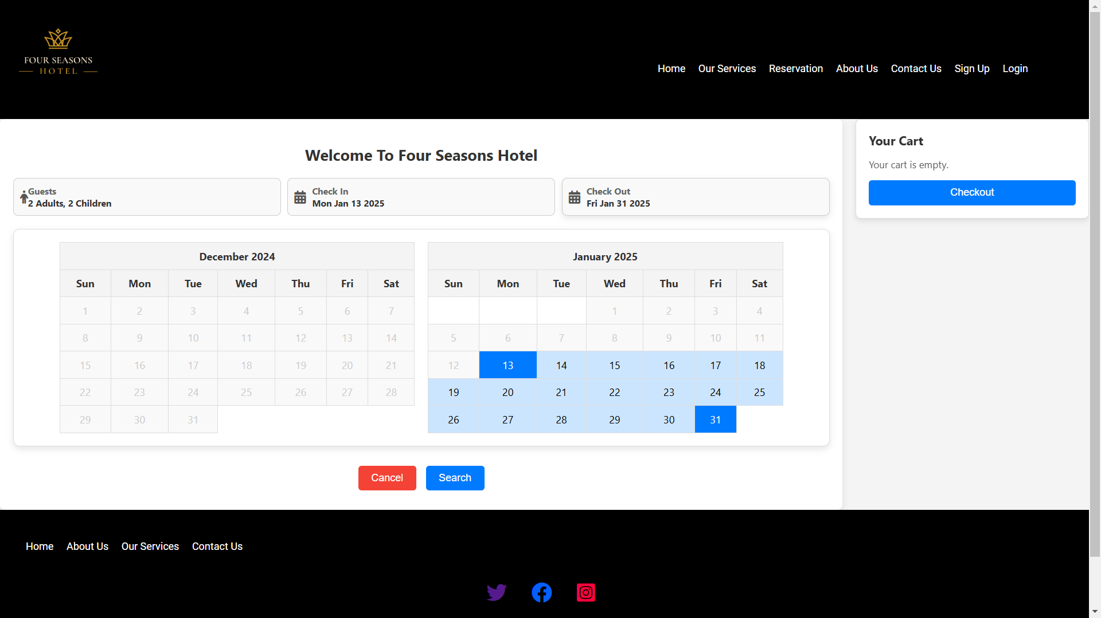Then the guest will select the dates of the check in/out and will press the search button.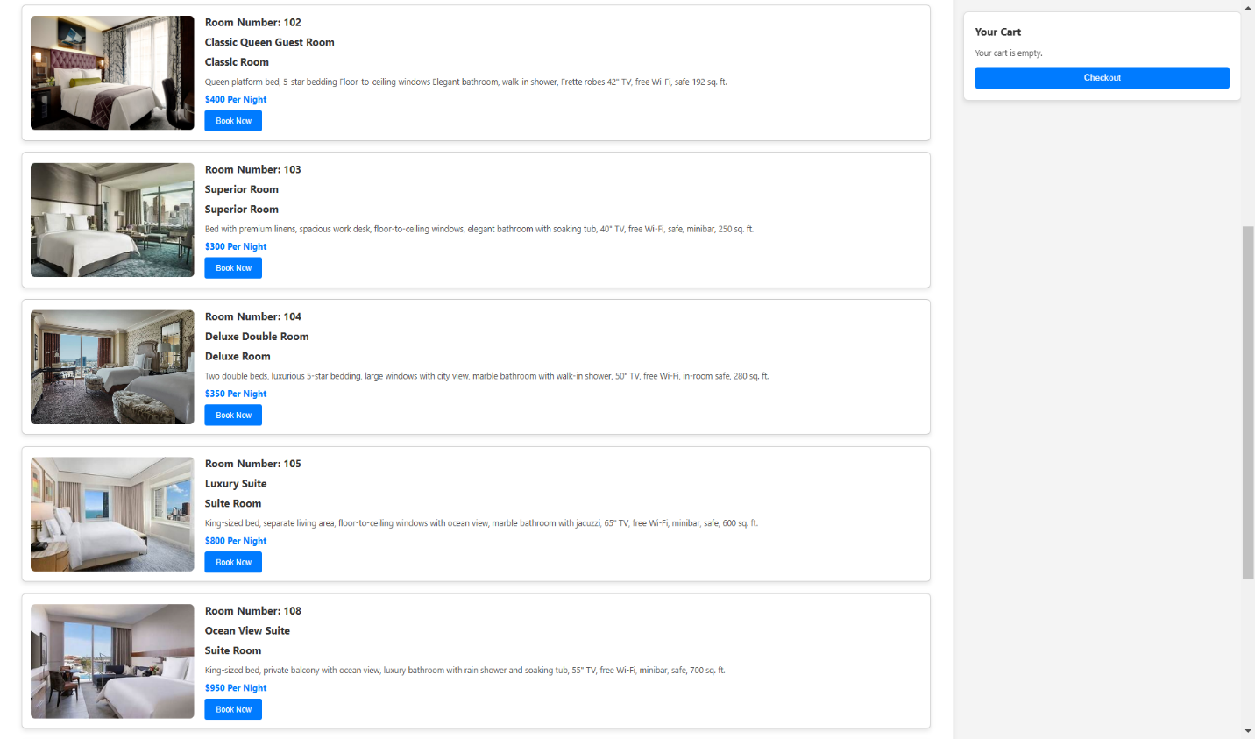after clicking the search button a list of rooms will be displayed with respect to other reservations. Example: guest1 booked a room from jan 7 till 23 with room number 103, if guest2 select a dates that is between these dates, the room will not be shown, example: guest2 select the dates jan 3 till 19 the room 103 will not be displayed, but if the guest select dates from jan 2 till jan 6 the roo m 103 will be displayed. After deciding, the guest will press the book now to procced to checkout.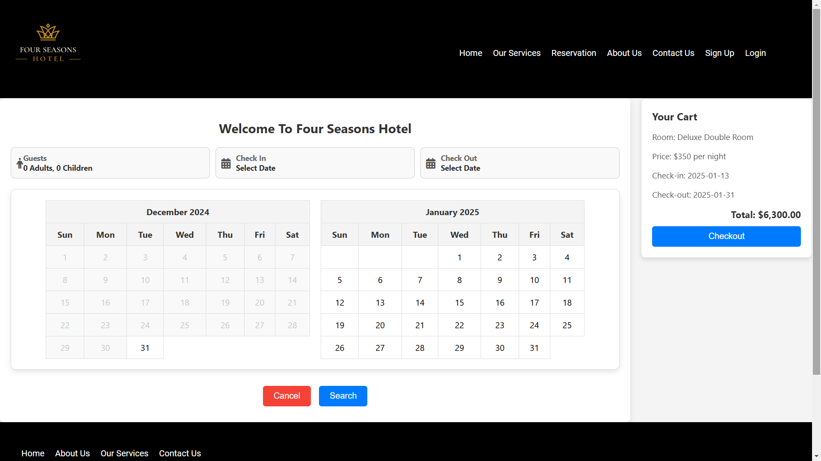After the guest will press book now the information of the room will be displayed in the cart and the total price with respect to how many days the guest will stay.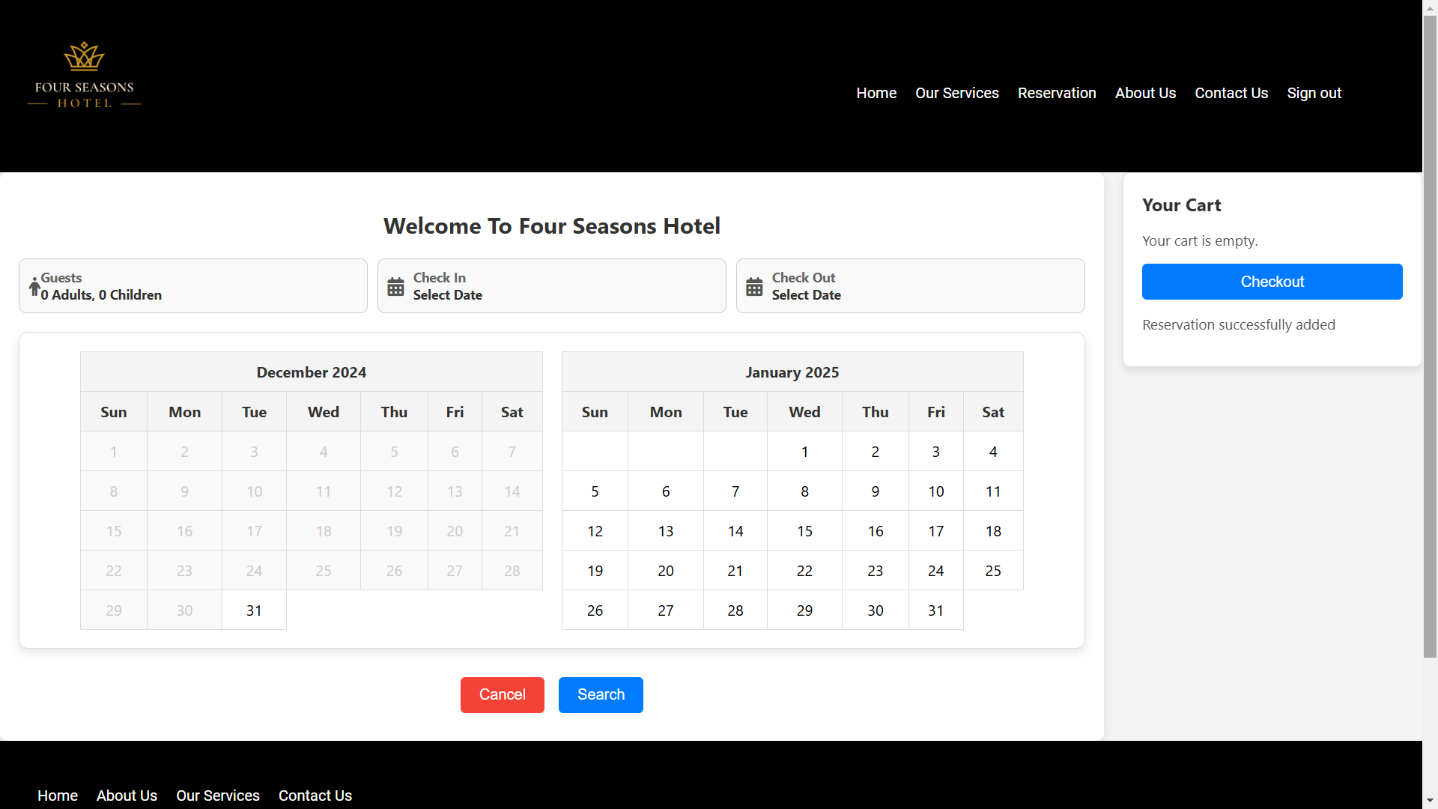

Finally, the user will press the checkout button, and the room is reserved for that guest.

**8.1.7.Request a Service**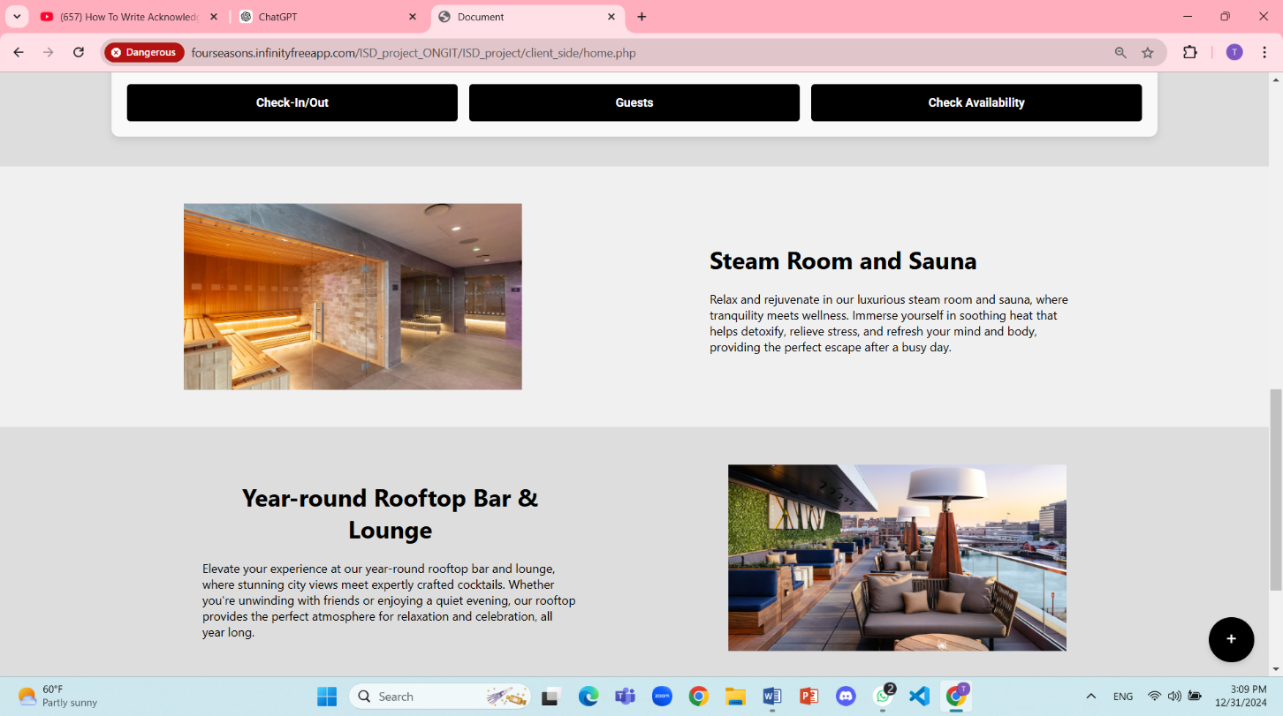

After the guest booked a room, a small button on the right bottom of the UI pages will be displayed.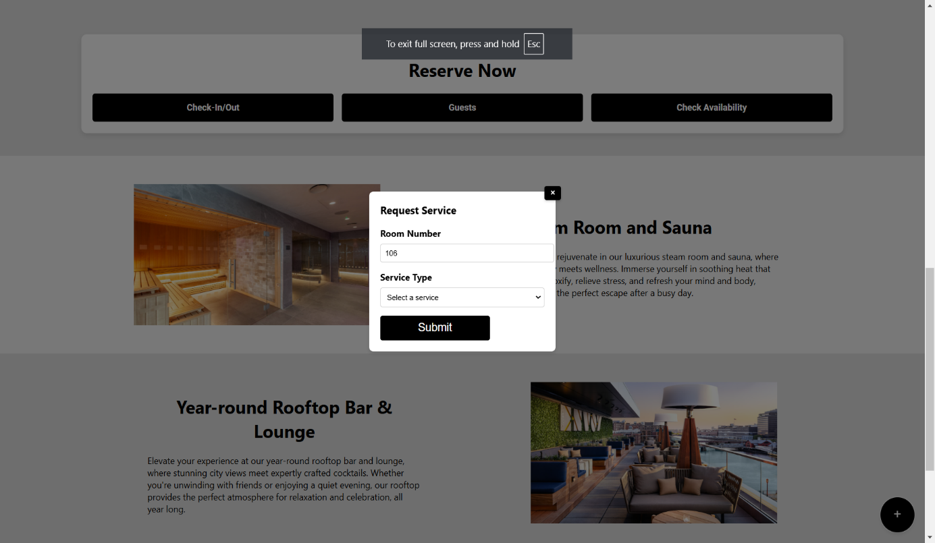

This popup is for requesting a service like: housekeeping, maintenance, or ordering food.

That’s all for the User Section.

## **8.2.Admin Section**

### **8.2.1.Client List**

|  |  |
| --- | --- |
| **As the admin login with his specific email and password the client list page will be displayed .This page will make the admin check reservation of a specific client and delete his account if the date created is more than 1 year** |  |
|  | |

### **8.2.2.Room List**

|  |  |  |
| --- | --- | --- |
| **The room list will show all rooms that can the admin view,modify a specific info or delete a room.** |  | |
|  | |  |

### **8.2.3.Employee list**

|  |  |
| --- | --- |
| **Employee list will show all employees with their credentials where the admin can delete an employee.** |  |

### **8.2.4.Feedbacks**

|  |  |
| --- | --- |
| **Here the admin can see the client’s feedbacks to improve the hotel system.** |  |

### **8.2.5.Client Requests**

|  |  |
| --- | --- |
| **In case of a problem,the admin can see every service requested by a client with the employee that served it.** |  |

### **8.2.6.Add Room**

|  |  |
| --- | --- |
| **The admin can add a room by providing the credentials. The room number cannot be as same as one of an existing room (it will cause an error).** |  |

### **8.2.7.Add Employee**

|  |  |
| --- | --- |
| **The admin can add an employee entering the required credentials. The email cannot be as an email for a client ,this will cause an error and vice versa.** |  |

# **9.Conclusion**

In conclusion, the **Hotel Management System** project successfully addresses the common challenges faced by both guests and hotel administrators. By providing a user-friendly platform for booking, managing reservations, and viewing real-time room availability, this system significantly enhances the guest experience and simplifies hotel operations. The automation of key processes, such as bookings and room management, reduces the risk of errors, improves efficiency, and ensures smoother communication between the hotel and its guests.

# **10.Future Work**

While the current version of the **Hotel Management System** is functional and effective, there are several opportunities for future improvements and features that could further enhance its capabilities:

**10.1.Mobile Application Development**: In the future, we plan to develop a mobile application version of the system to users who prefer to book rooms and manage their reservations on smartphones and tablets.

**10.2.Payment Integration:** We aim to integrate additional payment gateways to offer more payment options for guests, including mobile wallets and international payment systems, making the booking process even more convenient.

**10.3.Advanced Analytics:** Adding an analytics dashboard for hotel administrators would allow them to track trends, guest preferences, and financial data in real-time, helping them make informed decisions and improve customer service.

**10.4.Multilingual Support:** Implementing multilingual support for the website would allow users from different regions to interact with the platform in their preferred language.

**10.5.Loyalty Programs:** Integrating a loyalty program would reward repeat guests with discounts, special offers, and personalized experiences, helping the hotel build stronger relationships with its customers.

**10.6.AI-Powered Recommendations:** Adding an AI-driven recommendation engine could provide personalized suggestions for guests, such as room upgrades, packages, or dining options based on their past bookings and preferences.

With these future improvements, the **Hotel Management System** will continue to evolve and adapt to the changing needs of the hospitality industry, ensuring it remains at the forefront of innovation in hotel management and customer satisfaction.